**OBJECT ORIENTED PROGRAMMING LAB**

ASSIGNMENT: 7 DATE: 11-04-2023

SLOT: L3+L4 MAX MARKS: 10

Name:K.Kavyanjali Regno:22BCE9513

1. Write a Java program to design a banking application that displays the details of a Customer, Account Information, calculating interest etc using interfaces Supporting multiple inheritance.

**INPUT:**

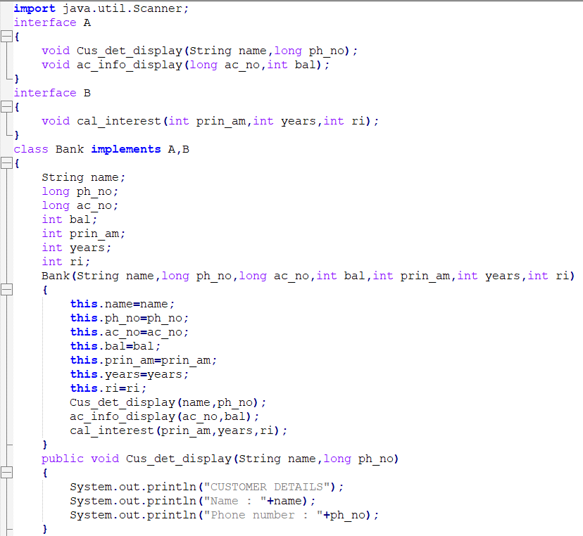

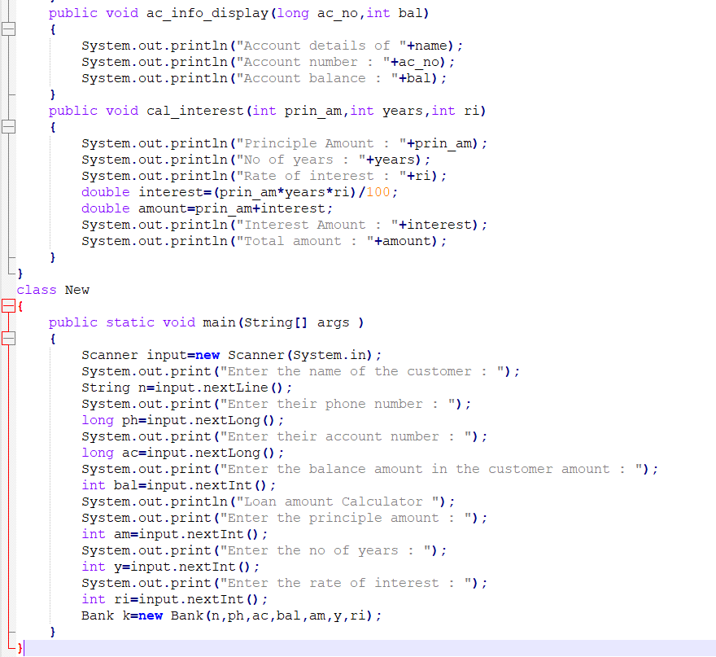

**OUTPUT:**

